Integrate Zscaler with Identity Providers
(IdPs) such as Azure AD, Okta, and Active
Directory for seamless authentication and
authorization.

Group Details:

S.NO | NAME | REGISTER NO | EMAIL ID
1 | MADHU SRI.P | 2326J1335 | madhusrimadhu638@gami.com
2 | SURIYA.K | 2326J1350 | suriyaalone243@gamil.com
3 | MEGANATHAN.S | 2326J1340 | sakash82205@gmail.com
4 | NITHISH.M | 2326J1344 | nithish875462@gmail.com
5 | MANOJ.R | 2326J1 | mtom95867@gmail.com

Project Details :

Title:
Integrate Zscaler with Identity Providers (IdPs) such as Azure AD, Okta, and Active Directory for seamless authentication and authorization. This project outlines the strategy and implementation plan for integrating the Zscaler security platform with our organization's core Identity Providers (IdPs): Microsoft Entra ID (Azure AD), Okta, and on-premises Active Directory (AD). The primary objective is to create a seamless, secure, and automated framework for userauthentication and authorization across all Zscaler services. By moving away from disparate local user management and leveraging these centralized identity sources, we aim to establish a true Zero Trust architecture where access is continuously verified based on user identity and context. This initiative will consolidate authentication into a single source of truth, enforce consistent security policies like Multi-Factor Authentication (MFA), and streamline the user experience through Single Sign-On (SSO). Ultimately, this integration will serve as the critical link between our identity infrastructure and our security enforcement point, ensuring that the right users have the s.no Name College Contact right level of secure access to the internet and applications, regardless of their location.
Abstract:

This project details the integration of the Zscaler Internet security platform with leading Identity Providers (IdPs), including Microsoft Entra ID (Azure AD), Okta, and on-premises Active Directory (AD). The primary objective is to establish a unified identity framework that enables seamless Single Sign-On (SSO) and centralized authorization for all Zscaler services. By consolidating authentication into trusted corporate directories, this initiative eliminates the need for disparate credentials and provides a foundational element for a modern Zero Trust security architecture. By leveraging industry-standard protocols such as SAML, OIDC, and SCIM, this integration ensures that user authentication is delegated to trusted corporate directories while enforcing consistent security policies, including Multi-Factor Authentication (MFA). This approach not only enhances the user experience by reducing password fatigue but also strengthens the organization's security posture by ensuring that every access request is verified by the identity provider before reaching Zscaler's security enforcement points. Furthermore, the implementation of automated user provisioning via SCIM streamlines lifecycle management, reducing administrative overhead and enhancing security posture. The outcome is a robust, identity-centric security model that aligns with Zero Trust principles, ensuring that only authenticated and authorized users gain secure access to internet and cloud applications from any location. This integration effectively bridges the gap between identity governance and network security, creating a dynamic and responsive access control environment.
Use Case Scenarios:

Use Case Scenario 1: Remote Faculty Access to Research Data
A research professor is working from an off-campus conference and needs secure access to
sensitive research data stored on an internal server. Instead of connecting to the full campus
network via VPN, ZPA grants access only to the specific research server. The professor
authenticates via the university's identity provider, and access is granted based on their role.

Output:

• User identity verified: Research_Faculty_Group
• Context-aware access enforced: Access allowed only from non-campus IP ranges
• Connection restricted: Limited to specific Research File Server (R&D_Server)
• Security enforcement: Multi-Factor Authentication (MFA) required due to off-network
location
• No lateral movement: User cannot access other internal systems such as HR or student records

Use Case Scenario 2: Student Access to Library Resources
A graduate student is off-campus and needs access to licensed academic journals and databases
hosted internally. Instead of requiring a full VPN tunnel, ZPA provides direct access to the
library application portal. The student authenticates via the identity provider, ensuring only
enrolled students can access paid subscription content.

Output:

• User identity verified: Enrolled_Student_Group
• Access scope defined: Limited to Library Portal and journal databases
• Policy enforcement: Access restricted to authorized users only, preventing credential sharing
• User experience: Seamless SSO without additional VPN client complexity
• No broad network access: Student cannot navigate to administrative systems or internal
servers

Use Case Scenario 3: HR Administrator Access to Payroll System
An HR administrator requires access to the payroll system to process monthly salaries. Access
must be restricted to specific work hours and require step-up authentication due to the sensitivity

of the data. The administrator authenticates via the identity provider, and ZPA enforces time-
based and MFA policies.

Output:

• User identity verified: HR_Payroll_Group
• Time-based restriction enforced: Access permitted only during business hours (8:00 AM –
6:00 PM)
• Step-up authentication: MFA triggered upon accessing the payroll application
• Connection restricted: Limited to Payroll Application Server
• Audit trail: Full session logging maintained for compliance purposes

Use Case Scenario 4: IT Helpdesk Remote Troubleshooting
An IT support technician needs to remotely troubleshoot a server issue while working from
home. ZPA provides Just-in-Time (JIT) access to the specific server requiring maintenance. The
technician authenticates via the identity provider, and administrative privileges are granted only
for the duration of the task.

Output:

• User identity verified: IT_Helpdesk_Group
• Just-in-Time access granted: Admin rights elevated only for the active session
• Connection restricted: Limited to the specific target server (Server-X)
• Privilege boundaries enforced: No access to other infrastructure components (databases,
domain controllers)
• Session monitoring: Real-time activity logging for security review

Use Case Scenario 5: Contractor Access to Project Management Tool
An external project manager contracted for a specific initiative needs access to the university's
project management tool (e.g., Jira or SharePoint). Access must expire automatically upon
contract completion. The contractor authenticates via the identity provider, and ZPA provisions
time-limited access based on group membership synchronized from Azure AD.

Output:

• User identity verified: External_Contractor_Group
• Time-bound access policy enforced: Account deprovisioned automatically after contract end
date
• Connection restricted: Limited to Project Management Application only
• Segmentation enforced: Contractor cannot discover or access internal resources like finance
systems or student databases
Stage-1
Title Of the Project: -

Replace and modernize legacy VPN architectures with a cloud-native Zscaler Zero Trust solution to reduce attack surface and lateral movement.

Overview: -
The integration of Zscaler with enterprise Identity Providers (IdPs) represents a fundamental shift in how organizations approach secure access to applications and resources. Traditional network security models relied on VPNs and perimeter-based defenses, which often granted excessive access and created lateral movement risks. By contrast, this project leverages Zscaler's ZeroTrust Exchange platform to verify identity at the application layer rather than the network layer. Thein tegration with leading IdPs such as Microsoft Entra ID, Okta, and on-premises Active Directory establishes a unified identity fabric across the organization. This ensures that users are authenticated consistently regardless of their location or device. The project eliminates the need for duplicate user directories and manual account management within Zscaler. It create seamless experience where users authenticate once and gain access to authorized resources. Security teams benefit from centralized control over authentication policies and user lifecycle management. The integration supports modern authentication standards including SAML, OIDC, and SCIM protocols. Ultimately, this foundation enables true Zero Trust security where identity becomes the primary control plane. Microsoft Entra ID integration serves as a cornerstone of this identity strategy for organizations heavily invested in the Microsoft ecosystem. The integration leverages SAML 2.0 to establish federated trust between Zscaler and Azure AD for seamless Single Sign-On. Users accessing Zscaler Internet Access or Zscaler Private Access portals are redirected to Azure AD for authentication. This allows organizations to enforce Azure AD Conditional Access policies during the authentication flow. Policies can require compliant devices, specific locations, or risk-based access controls before granting access to Zscaler. The integration extends beyond authentication to include automated user provisioning via the SCIM protocol. User accounts and group memberships are synchronized in real-time from Azure AD to Zscaler. This automation eliminates manual provisioning errors and ensures immediate deprovisioning when users leave the organization. Azure AD's extensive reporting and auditing capabilities provide visibility into authentication attempts. The result is a tightly integrated security posture that leverages Microsoft's identity capabilities to protect Zscaler-enforced resources.Okta integration provides a flexible and vendor-agnostic approach to identity management for Zscaler deployments. As a leading independent Identity Provider, Okta connects Zscaler to a wide ecosystem of applications and directories. The integration utilizes OpenID Connect (OIDC) for modern, API-friendly authentication to Zscaler services. This approach supports rich user context including profile attributes and group memberships for policy enforcement. Okta's Universal Directory serves as the authoritative source for user identities synchronized from various HR systems and directories. The Okta Integration Network (OIN) simplifies setup with pre-built ponnectors and configuration guides for Zscaler. Automated provisioning via SCIM ensures that user changes in Okta are reflected in Zscaler within minutes. Lifecycle management events such as user onboarding, role changes, and terminations trigger automatic updates in Zscaler. Okta's adaptive MFA policies add an additional security layer during Zscaler authentication requests. This integration delivers a seamless experience for users while providing administrators with centralized identity governance across all Zscaler services. On-premises Active Directory integration addresses scenarios where organizations are not ready for full cloud identity migration. Many institutions maintain extensive on-premises infrastructure with complex group policies and nested organizational units. The Zscaler Authentication Bridge (ZAB) enables secure LDAP communication between Zscaler cloud services and on-premises AD. This lightweight connector sits behind the firewall and initiates outbound connections to Zscaler, eliminating the need for inbound firewall rules. User authentication requests are securely proxied through ZAB to validate credentials against the on-premises domain controllers. Group membership information is synchronized to Zscaler for use in policy definitions and access decisions. This approach preserves investments in existing Active Directory infrastructure while enabling cloud-delivered security. Organizations can maintain strict access controls based on on-premises group memberships and organizational hierarchies.

List of Vulnerability Table:

S.no | Vulnerability Name | CWE - No
1 | Improper Access Control | CWE- 284: Improper Access Control
2 | Invalid Certificate | CWE-395: Improper Certificate Validation
3 | Missing X-Frame-Options | CWE-1021: Design Improper Restriction of Rendered UI Layers Frames
4 | X-Content-Type Options Header Missing | CWE -918: Server-Side Request Forgery
5 | Drupal Ajax API shows JSONP not disabled by default | CWE-937,1035: OWASP Top Ten 2013,2017 Category A9 - Using Components with Known Vulnerabilities
6 | Drupal Api Vulnerability | CWE-20: Improper Input Validation
7 | Improper API Filtration | CWE-79: Improper Neutralisation of Input During Web Page Generation ('Cross-site Scripting')
8 | Denial of Service | CWE -400: Uncontrolled Resource Consumption
9 | TLS Version 1.0 Protocol Detection | CWE-327: Use of a Broken or Risky Cryptographic Algorithm
10 | web.config File Information Disclosure | CWE-497: Exposure of Sensitive System Information to an Unauthorised Control Sphere

REPORT: -

1)Vulnerability Name: Improper Access Control
CWE/CVE :- CWE- 284
OWASP Category: A01:2021-Broken Access Control
Description: The product does not restrict or incorrectly restricts access to a resource from an unauthorized actor.

Business Impact: This vulnerability is significant, as it can lead to unauthorized access to sensitive data or files, potentially causing data breaches, privacy violations, and loss of user trust. Affected sites may also require configuration changes after applying a security release.
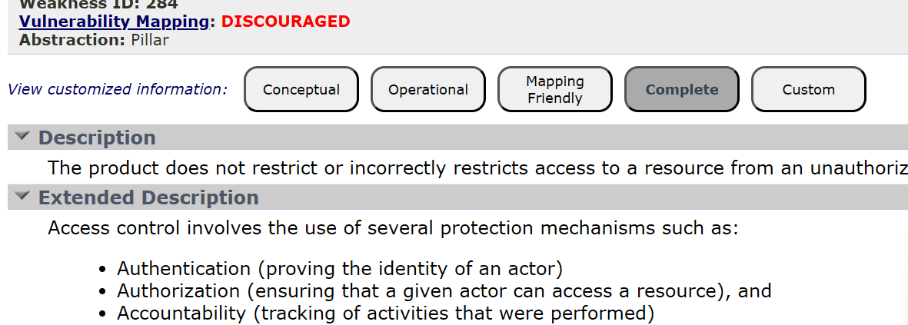

2)Vulnerability Name: Invalid Certificate
CWE-395: Improper Certificate Validation
OWASP Category: A07:2021 – Identification and Authentication Failures
Description: When a certificate is invalid or malicious, it might allow an attacker to spoof a trusted entity by interfering in the communication path between the host and client.

Business Impact: Improper certificate validation can lead to a range of security threats which includes Man-in-the-middle attacks(Attackers can intercept communication between two parties and read or modify the data exchanged between them),Data breaches:(Attackers can gain unauthorized access to sensitive information or sensitive systems, leading to data breaches),Malware distribution(Attackers can use fake digital certificates to distribute malicious software or infect systems with malware)
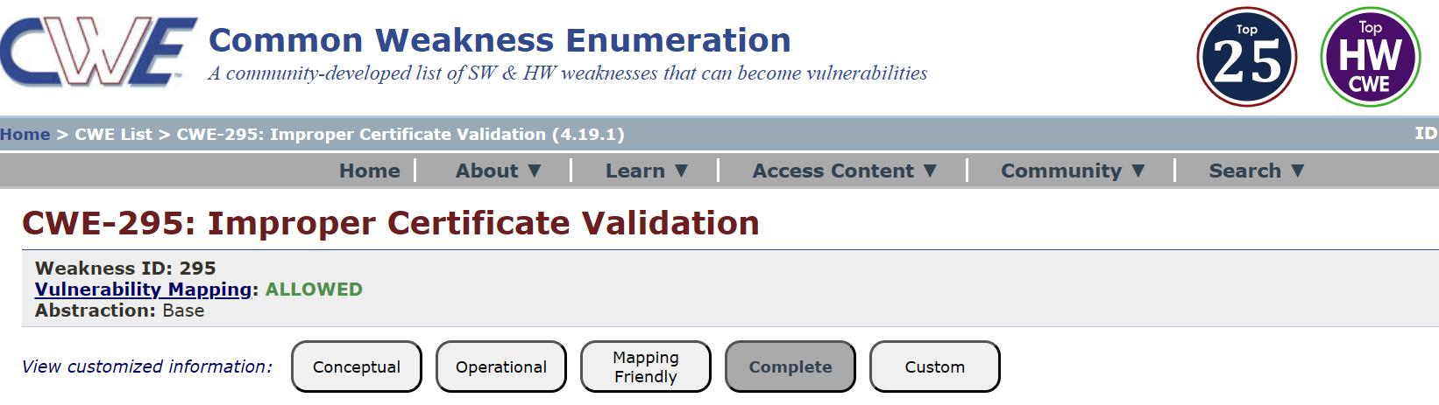

3)Vulnerability Name: Missing X-frame-Options Header
CWE-1021: Design Improper Restriction of Rendered UI Layers or Frames
OWASP Category: A04:2021-Insecure Design
Description: A web application is expected to place restrictions on whether it is allowed to be rendered within frames, iframes, objects, embed or applet elements.
Business Impact: This enables path to the attackers to manipulate or gain unauthorized access touser interface elements, potentially leading to deceptive or malicious user interactions
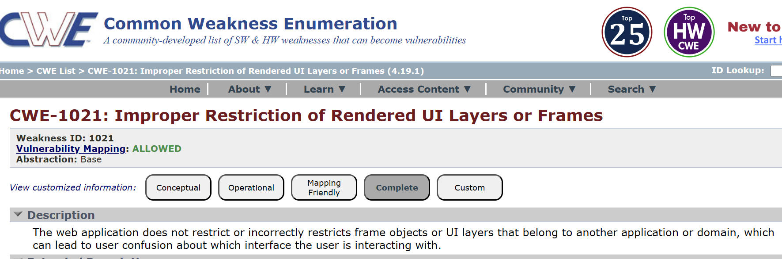
4)Vulnerability Name: X-Content-Type Options Header Missing
CWE -918: Server-Side Request Forgery (SSRF)
OWASP Category: A10:2021 – Server-Side Request Forgery (SSRF)
Description: The web server receives a URL or similar request from an upstream component and retrieves the contents of this URL, but it does not sufficiently ensure that the request is being sent to the expected destination.
Business Impact: The header missing impact Data Exposure(Attackers might force the server to render sensitive data as HTML, leading to data exposure),Security Risks(Content type manipulation can increase security risks, potentially leading to breaches, data leaks, and unauthorized access).
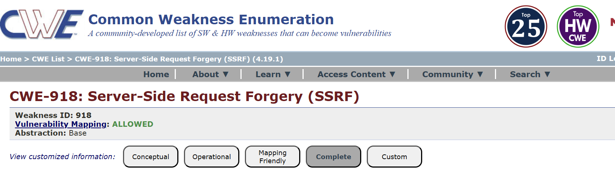
5)Vulnerability Name: Drupal Ajax API shows JSONP not disabled by default
CWE-937,1035: OWASP Top Ten 2013,2017 Category A9 - Using Components with Known Vulnerabilities
OWASP Category: A06:2021-Vulnerable and Outdated Components
Description: Vulnerable and outdated components refer to using software libraries, modules, or dependencies within a web application that have known security issues or are not updated to the latest secure versions.
Business Impact: The presence of vulnerable and outdated components in a web application poses significant security risks. Attackers can exploit these weaknesses to gain unauthorized access, inject malicious code, steal sensitive data, or disrupt the system's operation.
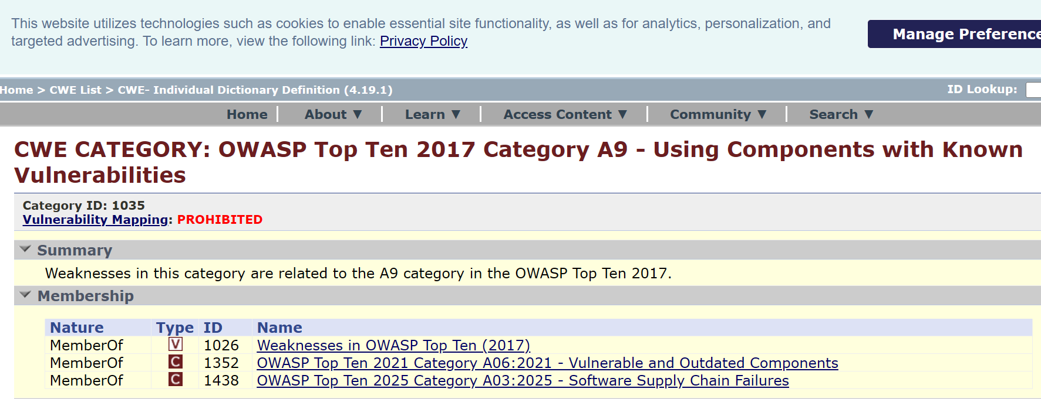
6)Vulnerability Name: Drupal Api Vulnerabillity
CWE-20: Improper Input Validation
OWASP Category: A03:2021 – Injection
Description: The product receives input or data, but it does not validate or incorrectly validates that the input has the properties that are required to process the data safely and correctly.
Business Impact: The impact of a successful SQL injection attack can be devastating for businesses. It can result in unauthorized access to sensitive information, data theft, financial losses, damage to reputation, and legal consequences.
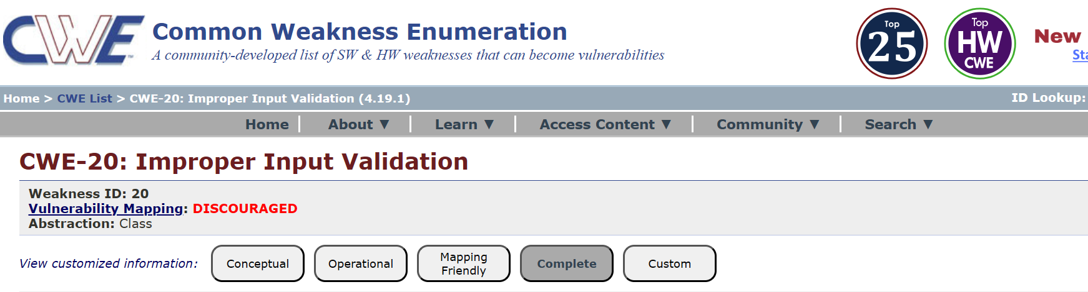

7)Vulnerability Name: Improper API Filtration
CWE-79: Improper Neutralization of Input During Web Page Generation ('Cross-site Scripting')
OWASP Category: A07-2017: Cross-site Scripting (XSS)
Description: The product does not neutralize or incorrectly neutralizes user-controllable input before it is placed in output that is used as a web page that is served to other users.
Business Impact: If exploited, this vulnerability allows attackers to inject malicious scripts into web pages, which can be viewed by other users. compliance violations and legal liabilities.
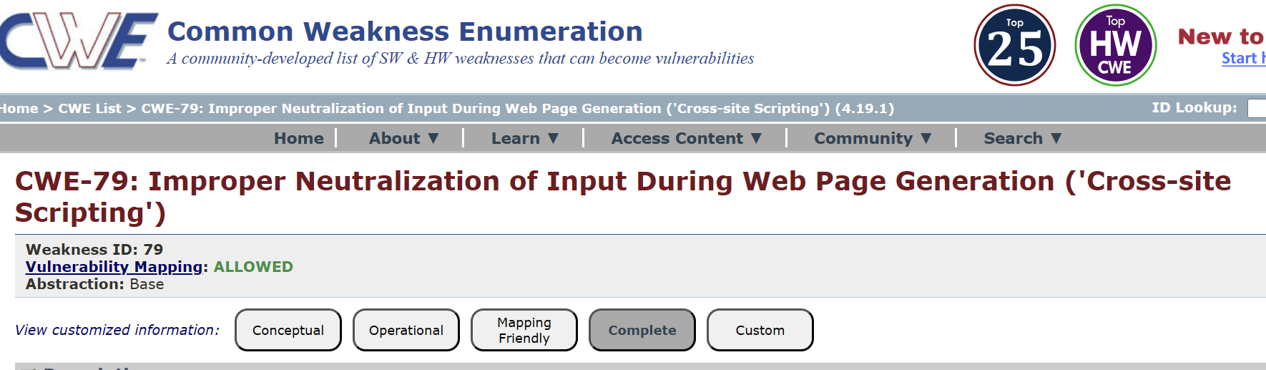

8)Vulnerability Name: Denial of Services
CWE -400: Uncontrolled Resource Consumption
OWASP Category:
Description: The Denial of Service (DoS) attack is focused on making a resource (site, application, server) unavailable for the purpose it was designed. There are many ways to make a service unavailable for legitimate users by manipulating network packets, programming, logical, or resources handling vulnerabilities, among others.
Business Impact: If successfully exploited, it involves overwhelming a system or application with excessive demands on its resources. This can lead to a range of disruptive consequences..
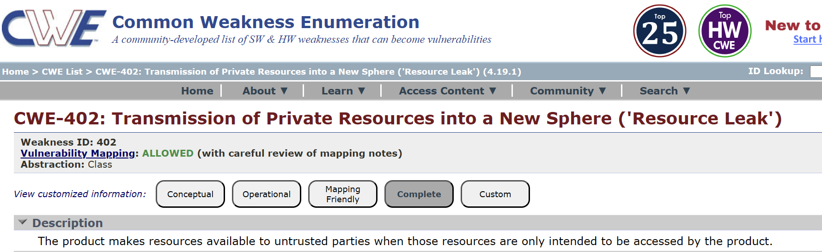

9)Vulnerability Name: TLS Version 1.0 Protocol Detection
CWE-327: Use of a Broken or Risky Cryptographic Algorithm
OWASP Category: A02:2021-Cryptographic Failures
Description: The product uses a broken or risky cryptographic algorithm or protocol.
Business Impact: TLS 1.0 is an outdated and vulnerable encryption protocol, and its use can expose sensitive data to potential security threats. This not only jeopardizes the integrity of customer information and payment details but also tarnishes the company's reputation.
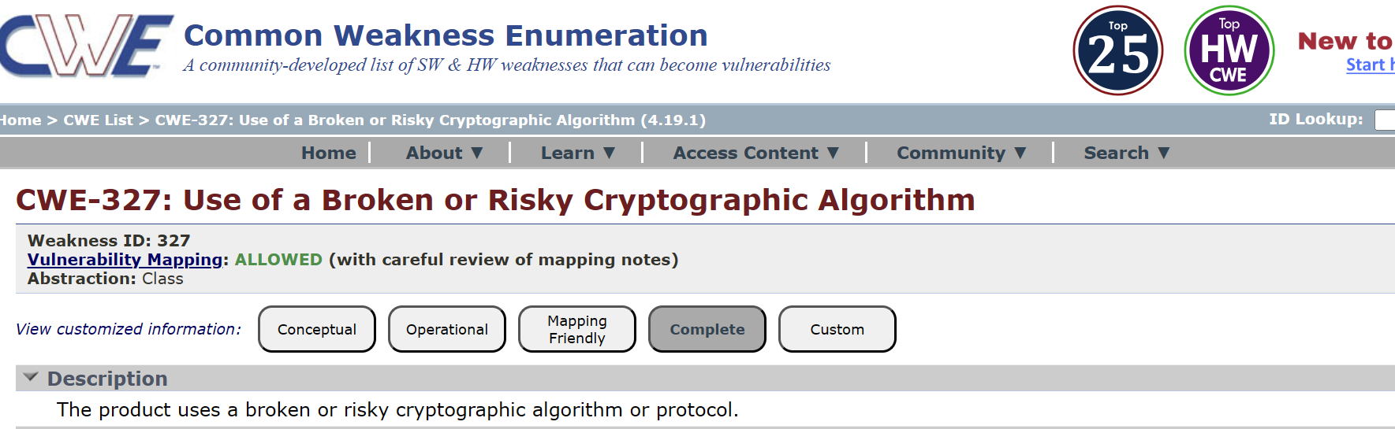

10)Vulnerability Name: web.config File Information Disclosure
CWE-497: Exposure of Sensitive System Information to an Unauthorized Control Sphere
OWASP Category: A3:2017-Sensitive Data Exposure
Description: An information disclosure vulnerability exists in the remote web server due to the disclosure of the web.config file.
Business Impact: It exposes sensitive configuration details, including database connection strings and encryption keys, to potential attackers. This could lead to unauthorized access, data breaches, and system compromise.
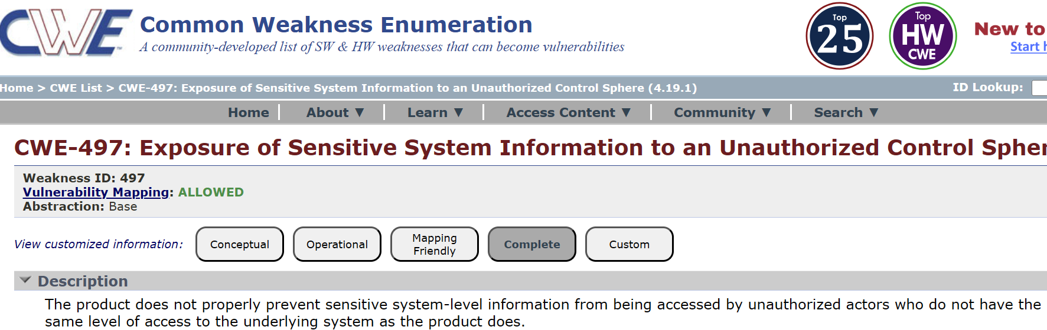

Stage 2
Overview :-
Nessus is a vulnerability scanner developed by Tenable, Inc. It is are mote scanner, meaning that it does not need to be installed on the target host to scan it. Nessus works by sending a variety of probes to the target host in order to identify vulnerabilities. These probes can include network traffic, operating system commands, and application requests. Nessus uses a plugin-based architecture. Plugins are small pieces of code that are designed to identify specific vulnerabilities. There are over 1200 plugins available for Nessus, covering a wide range of vulnerabilities in operating systems, applications, and network devices. When Nessus scans a host, it first uses a discovery plugin to identify the operating system and services running on the host. Once the host has been discovered, Nessus runs a series of plugins to test for vulnerabilities. For each vulnerability that Nessus finds, it provides a detailed report that includes the severity of the vulnerability, the steps to reproduce the vulnerability, and the steps to remediate the vulnerability.

List of vulnerability:-

s.no | Vulnerability name | Severity | plugins
1 | TLS Version 1.0 Protocol Detection | MEDIUM | 104743
2 | TLS Version 1.1 Protocol Deprecated | MEDIUM | 157288
3 | Additional DNS Hostnames | INFO | 46180
4 | Apache Tomcat Detection | INFO | 39446
5 | Device Type | INFO | 54615

REPORT: -

1) Vulnerability Name: - TLS Version 1.0 Protocol Detection
Severity: - MEDIUM
Plugin: - 104743
Port: - 443
Description: - The remote service accepts connections encrypted using TLS 1.0. TLS 1.0 has a number of cryptographic design flaws. Modern implementations of TLS 1.0 mitigate these problems, but newer versions of TLS like 1.2 and 1.3 are designed against these flaws and should be used whenever possible.
Solution: - Enable support for TLS 1.2 and 1.3, and disable support for TLS 1.0. Business Impact: -Continued use of TLS 1.0's encryption, known for its inherent cryptographic flaws, exposes the organization to heightened security risks, increasing the likelihood of data breaches and cyberattacks.
Business Impact: -Continued use of TLS 1.0's encryption, known for its inherent cryptographic flaws, exposes the organization to heightened security risks, increasing the likelihood of data breaches and cyberattacks.

2)Vulnerability Name: - TLS Version 1.1 Protocol Deprecated
Severity: - MEDIUM
Plugin: - 157288
Port: - 443
Description: - The remote service accepts connections encrypted using TLS 1.1. TLS 1.1 lacks support for current and recommended cipher suites.
Solution: - Enable support for TLS 1.2 and/or 1.3, and disable support for TLS 1.1.
Business Impact: -The continued use of TLS 1.1 with its lack of support for modern cipher suites and advanced encryption methods jeopardizes the organization's security posture, increasing vulnerability to cyber threats and potential data breaches.

3)Vulnerability Name: - Additional DNS Hostnames
Severity: - LOW
Plugin: - 83875
Port: - 443
Description: - The remote host allows SSL/TLS connections with one or more Diffie-Hellman moduli less than or equal to 1024 bits.
Solution: - Reconfigure the service to use a unique Diffie-Hellman moduli of 2048 bits or greater.
Business Impact: - Allowing SSL/TLS connections with weak Diffie-Hellman moduli raises security concerns. An attacker with sufficient resources and computing power could compromise the shared secret relatively quickly, potentially leading to the decryption of sensitive data or the violation of connection integrity.

4)Vulnerability Name: -Apache Tomcat Detection
Severity: - INFO
Plugin: - - 46180
Port: - 0
Description: - Hostnames different from the current hostname have been collected by miscellaneous plugins. Nessus has generated a list of hostnames that point to the remote host. Note that these are only the alternate hostnames for hosts discovered on a web server.
Solution: - - If you want to test them, re-scan using the special vhost syntax, such as : www.example.com [192.0.32.10]
Business Impact: -This does not pose an immediate threat to business operations or data security.

5)Vulnerability Name: - Device Type
Severity: - INFO
Plugin: - 54615
Port: - 0
Description: - Based on the remote operating system, it is possible to determine what the remote system type is (eg: a printer, router, general-purpose computer, etc).
Solution: -
Business Impact: - It allows for the identification of the remote system type, such as a printer, router, or general-purpose computer, based on the remote operating system. While this

Stage-3
Report:

Title: - Integrate Zscaler with Identity Providers (IdPs) such as Azure AD, Okta, and Active Directory for seamless authentication and authorization.

Overview:
Integrating Zscaler with Identity Providers (IdPs) such as Microsoft Azure Active Directory enables organizations to implement secure and centralized user authentication for accessing internet and cloud applications. This integration allows Zscaler to use Azure AD for verifying user identities before granting access to network resources. The integration is typically implemented using authentication protocols such as SAML (Security Assertion Markup Language), which enables Single Sign-On (SSO). With SSO, users can log in once using their Azure AD credentials and securely access multiple applications and services without needing to re-enter their login information. By connecting Zscaler with Azure AD, organizations can centrally manage user identities, enforce security policies, and monitor user access from a single platform. Azure AD handles identity verification, while Zscaler provides cloud-based security services such as secure web gateway, traffic inspection, and access control. This integration also supports modern security models such as Zero Trust, where every access request is verified based on user identity, device status, and security policies. As a result, organizations can improve security, simplify user management, and provide a seamless access experience for users across different locations and devices.
Identity:
Identity plays a crucial role when integrating Zscaler with Identity Providers (IdPs) like Microsoft Azure Active Directory. In this integration, identity refers to the digital identity of a user that is used to authenticate and authorize access to network resources, applications, and internet services. When Zscaler is integrated with Azure AD, the identity provider is responsible for verifying the user’s identity before granting access. Azure AD authenticates the user using credentials such as usernames, passwords, or multi-factor authentication (MFA). After successful authentication, the identity information is securely passed to Zscaler using authentication protocols like SAML (Security Assertion Markup Language). Zscaler then uses this identity information to apply security policies based on the authenticated user. This allows organizations to enforce identity-based access control, where different users or groups receive different levels of access depending on their roles, departments, or security requirements. By using identity-based authentication, organizations can improve security, enable Single Sign-On (SSO), and ensure that only authorized users can access network resources. It also helps administrators centrally manage user identities and access permissions, making security management more efficient and scalable across cloud and enterprise environments.

Device posture:
Device posture refers to the security status and compliance level of a device attempting to access organizational resources. When integrating Zscaler with Identity Providers such as Microsoft Azure Active Directory, device posture plays an important role in ensuring that only secure and compliant devices are allowed to access applications and internet resources. In this integration, Azure AD can evaluate device compliance based on security policies such as operating system updates, antivirus status, device encryption, and device registration. These checks are usually enforced through conditional access policies. Once a user attempts to log in, Azure AD verifies both the user identity and the security posture of the device. After successful verification, the authentication information is passed to Zscaler through protocols like SAML, and Zscaler enforces network security policies based on the authenticated user and device status. If the device does not meet the required security standards, access can be restricted, limited, or denied. Device posture verification helps organizations implement a Zero Trust security model, where access decisions are based not only on user identity but also on the security condition of the device being used. This approach reduces the risk of compromised or unmanaged devices accessing sensitive corporate resources. Overall, integrating device posture checks with Zscaler and Azure AD enhances security by ensuring that only authorized users on secure and compliant devices can access organizational systems and applications.

Application risk:
Application risk refers to the potential security threats or vulnerabilities associated with the applications that users access within an organization’s network. When integrating Zscaler with Identity Providers such as Microsoft Azure Active Directory, application risk management becomes an important component of securing access to cloud and web applications. Through this integration, Azure AD verifies the identity of users before granting access, while Zscaler monitors and controls access to applications based on security policies. Zscaler can categorize applications based on their risk levels, such as high- risk, medium-risk, or low-risk applications. This classification helps organizations control which applications users are allowed to access. If a user attempts to access a high-risk or unapproved application, Zscaler can block or restrict that access according to the organization’s security policies. At the same time, Azure AD ensures that only authenticated and authorized users can attempt to access these applications. Managing application risk helps organizations prevent data leakage, reduce exposure to malicious applications, and ensure that employees use only approved and secure applications. This approach strengthens overall security while allowing organizations to safely adopt cloud services and web-based tools. Overall, integrating Zscaler with Azure AD enables organizations to combine identity-based authentication with application-level security controls, helping reduce risks associated with unauthorized or unsafe application usage.

Context aware access:
Context-aware access is a security approach that grants or restricts access to resources based on contextual information such as user identity, device posture, location, time, and risk level. When integrating Zscaler with Identity Providers (IdPs) like Microsoft Azure Active Directory, context-aware access helps organizations make smarter and more secure access decisions. In this integration, Azure AD authenticates the user and evaluatescontextual factors such as the user’s login location, device compliance status, and authentication method (for example, whether Multi-Factor Authentication (MFA) is used). Based on these factors, Azure AD can apply conditional access policies that determine whether the user should be granted, limited, or denied access. Once the user is authenticated, Zscaler applies additional security controls by inspecting and managing the user’s internet and application traffic. Zscaler can enforce policies based on the samecontextual information, such as blocking access from risky locations, restricting access from unmanaged devices, or allowing access only to approved applications. Context-aware access supports the Zero Trust security model, where no user or device is automatically trusted. Every access request is evaluated based on multiple security factors before granting permission.

Conclusion:-

Stage 1:
In the first stage, integrating Zscaler with Microsoft Azure Active Directory establishes secure identity-based authentication. Users are verified through Azure AD using protocols such as SAML, enabling Single Sign-On (SSO) and centralized identity management. This stage ensures that only authenticated users can access organizational resources.

Stage 2:
In the second stage, security policies and device posture checks are implemented. Azure AD evaluates user context and device compliance through conditional access policies, while Zscaler enforces web security controls such as traffic inspection, web filtering, and threat protection. This stage strengthens access control by ensuring that both the user and the device meet security requirements.

Stage 3:
In the final stage, the integration supports advanced security practices such as context-aware access and the Zero Trust model. Access decisions are continuously evaluated based on user identity, device status, location, and application risk. This stage helps organizations achieve stronger protection, better visibility, and secure access to applications from any location or device.

Future Scope:-

Stage 1:
In the future, integration between Zscaler and Microsoft Azure Active Directory can further enhance identity management by adopting stronger authentication methods such as passwordless authentication, biometric verification, and advanced Multi-Factor Authentication (MFA).Organizations may also improve identity lifecycle management to automatically manage user access when employees join, move, or leave the organization.

Stage 2:
Future developments may include deeper device posture assessment and real-time monitoring of device health and compliance. Advanced endpoint security tools and automated threat detection can be integrated with Zscaler and Azure AD to quickly identify compromised devices and restrict access, improving overall security visibility and response capabilities.

Stage 3:

In the long term, the integration can evolve to support more advanced Zero Trust architectures with the help of artificial intelligence and machine learning. These technologies can analyze user behavior, detect anomalies, and dynamically adjust security policies. This will allow organizations to provide more adaptive, intelligent, and secure access to cloud applications and enterprise resources across global and hybrid work environments.

Overall Future Scope:
The future scope of integrating Zscaler with Identity Providers such as Microsoft Azure Active Directory lies in strengthening identity-based security and improving secure access to cloud applications. Organizations will increasingly adopt advanced authentication methods such as passwordless login, biometric authentication, and enhanced Multi-Factor Authentication (MFA) to provide stronger protection for user identities. In addition, future developments will focus on improved device posture assessment, continuous security monitoring, and automated threat detection to ensure that only secure and compliant devices can access organizational resources. Artificial intelligence and machine learning technologies may also be used to analyze user behavior and detect suspicious activities in real time.

Tools Explored : Owasp top 10,Scanning,Vulnerability,Awareness,Identity,Policy Configuration.
Topics Explored : Zscaler,Nessus,Owasp,Zscaler Private Access,Zscaler Zero Trust Exchange.

THE END

